

HTML5

Semester: 1 |  | Curriculum Code:
Duration: 90 minutes |  | Total Marks: 20



Practical Examination Paper
1. Note & Requirements
+ In this exam, student will make a simple student management page.
+ All css must be saved in 1 external stylesheet named: mysite.css
+ Icons to the left of menu’s items are not required.
+ You’re free to use either Dreamweaver, Notepad, Notepad++, Eclipse, Netbean, Visual Studio… etc. to do the exam. However, DO NOT use any external template, pre-made CSS / Javascript or Dreamweaver generated code in this exam. All HTML, CSS and Javascript must be coded manually except following:
+ Included library: jquery-3.3.1.min.js

2. Home Page [6 mark]
-Create a document named index.html as below screenshot: [2]
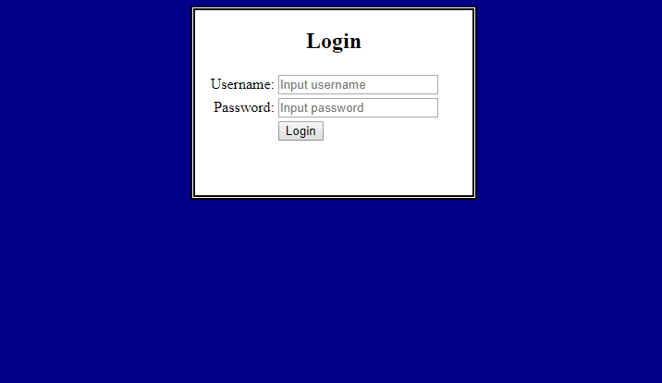
Notes: [2]
- Headline is using h2
- Page background dark blue
- Main area border: double style, 5px width, black color
- Main area must be aligned center, width 300px, height 200px
- Text entered to Password textbox must be masked (see below screen shot)
- All label must align right.
- All textboxes and button must align left at same position as per design.
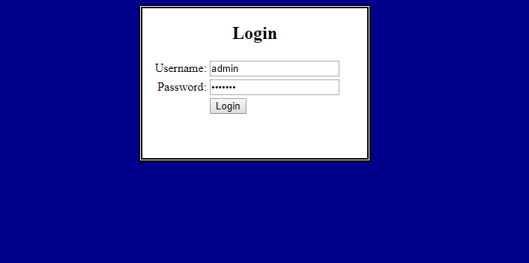
Event: [2]
- When user click login, check if username = “admin” and password = “123456”
- If username and password matched, inform user that login success and re-direct user to nextpage.html (as per screen shot)
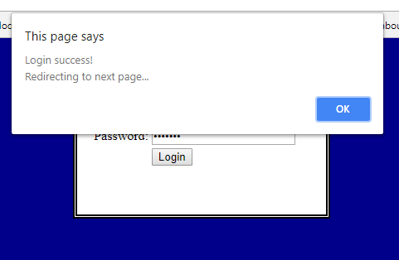
- If username and password not matched, inform user that login failed (as per screen shot)
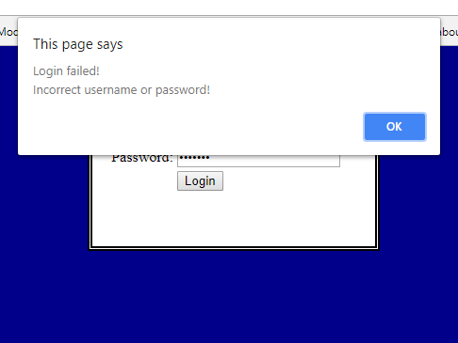

3. NextPage.html [14 mark]
-Create a document named nextpage.html as below screenshot:
- Form to input student information [2]
- Table to show current students’ information [2]
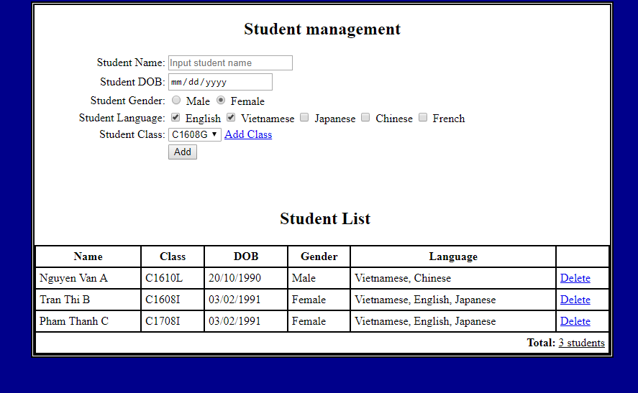
Note: [2]
- Main body width should be 800px
- Table border must be single, text in every cell must be padded 5px from any border.
- Student Name is required. If user forget to input, inform user to input it as per screenshot.
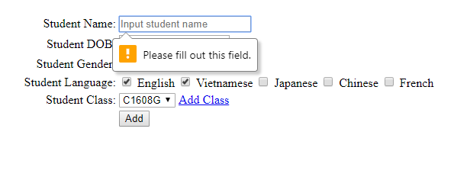
- Student DOB must be able to show a calendar so user can input as text or click on calendar to choose the date, as per screenshot
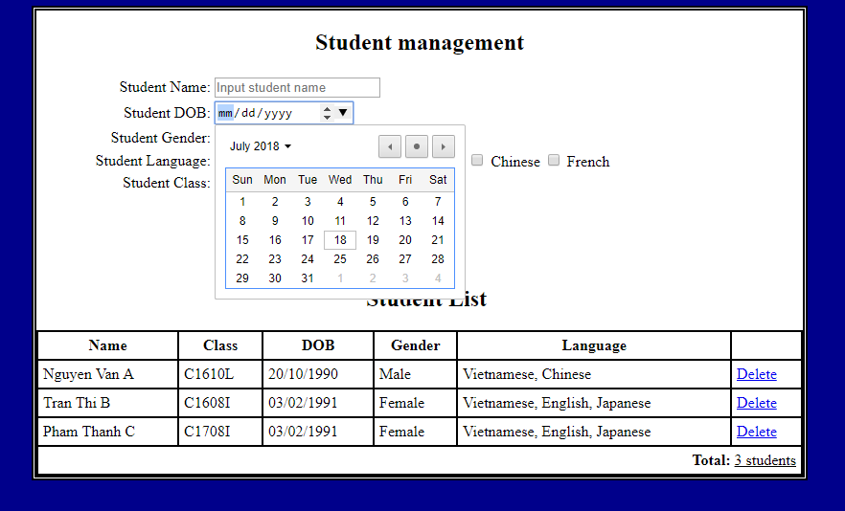
Event: [8 mark: 2 - Add Class, 3 – Add, 3 - Delete]
- When user click “Add Class”, show a prompt to ask user to enter class name (as per screenshot)
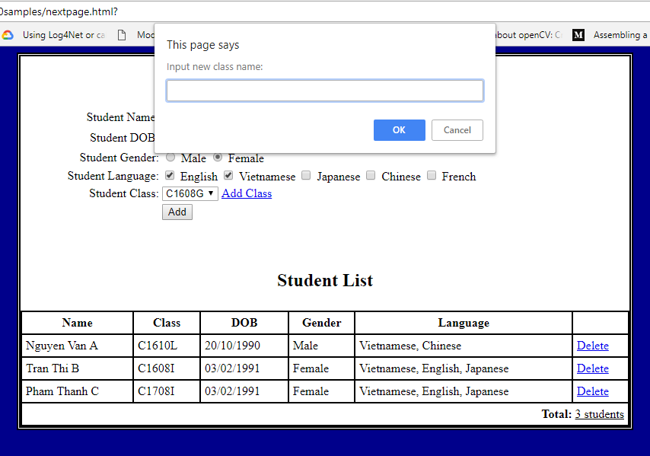
- If user input new class name, add it to the select box and inform user that the class added successfully. If user leave the input blank, do not perform add.
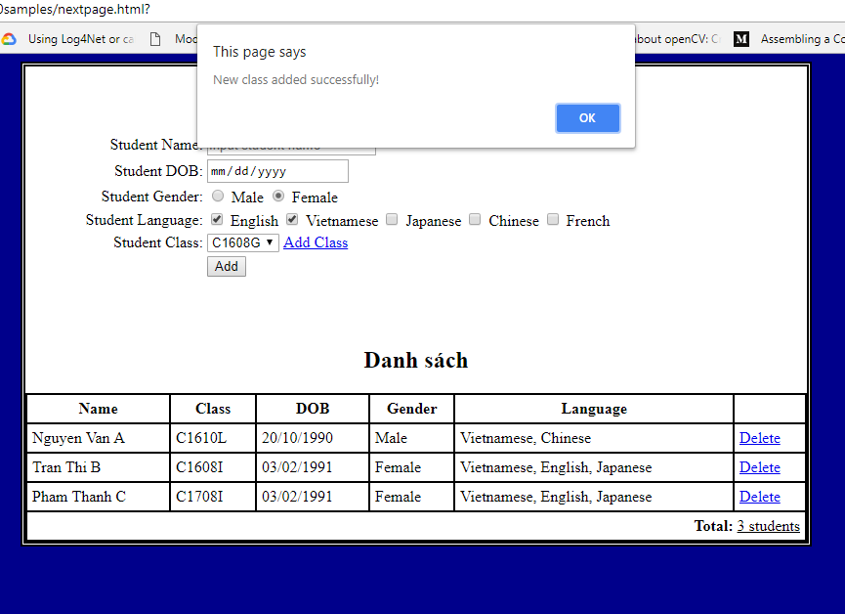
If user click on “Add” button, add a new row to the list table below with all inputted information. After that, clear the form.
If user click on “Delete” button, show a confirm.
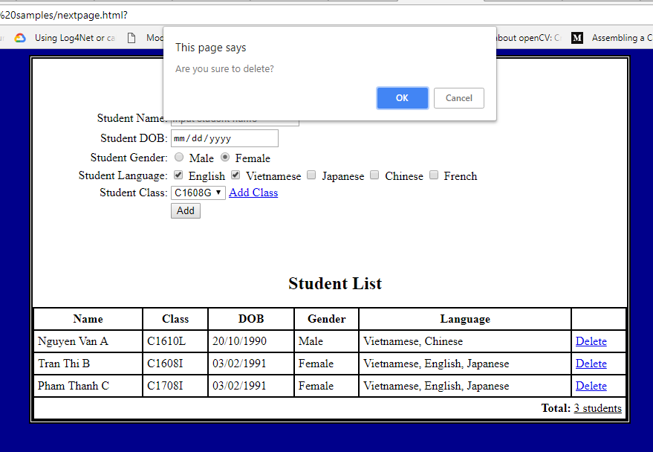
If user choose “No”, do not do anything. If user choose “Yes”, remove the chosen row from the list table, then inform user that it has been deleted successfully as per screenshot.
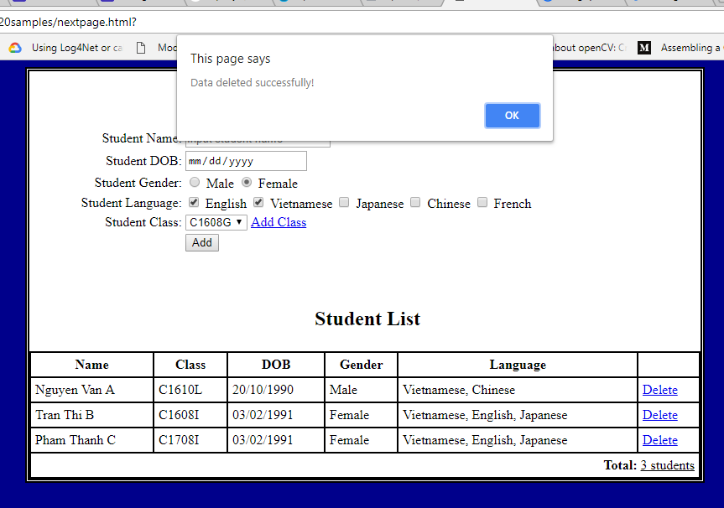

----------------------THE END-------------------------

